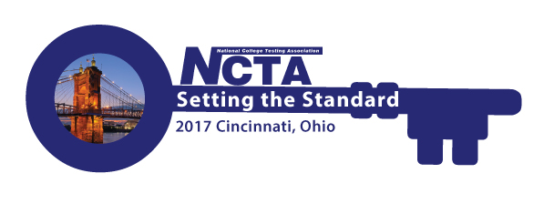
NCTA 2017 Annual Conference Committee Meeting
Monday, July 19, 2017
2:00 PM Eastern Time
GoToMeeting
https://global.gotomeeting.com/join/554423357

You can also dial in using your phone.
United States: +1 (646) 749-3112

Access Code: 554-423-357

Agenda

- Roll Call - Jody Atkins
- Conference Planner Updates – Jody Atkins
    - Registration Report
    - Housing Report
    - Agenda Discussion
    - Registration Giveaways
- Committee Updates – Cindy James (chair)
- Sponsorships/Exhibits – Rosemary Freer/Jody Atkins
- Marketing – Cindy James
- Program – Jim Wollack/Bob Lang
- Virtual Conference – David Espinoza
- Resource Fair – Jamila Maxie
- Host Committee – Paula Doughman
- Conference App – Amystique Church
  - Other/New Business
- Adjourn

